

**BASIS DATA**

INF1123

**LAPORAN PRAKTIKUM 1 : Dasar-Dasar MySQL**

Oleh :

*Akhmad Qasim*

*2211102441237*

Teknik Informatika

Fakultas Sains & Teknologi

Universitas Muhammadiyah Kalimantan Timur

Samarinda, 2023

**Laporan Praktikum 1:**

**Dasar-Dasar MySQL**

**Pokok Bahasan:**

* Mengetahui Dasar-Dasar MySQL
* Membuat Database
* Membuat *Table*
* Mengenal Constraint

**Tujuan Pembelajaran:**

* Mahasiswa dapat mengetahui, memahami, menguasai dan mampu mengimplementasi teori, konsep dan prinsip pemrograman database MySQL dengan logika pemrograman yang benar, ringkas, dan tepat dalam penerapannya di bidang teknologi informasi.

**Percobaan & Latihan:**

1. create database latihan1;  
   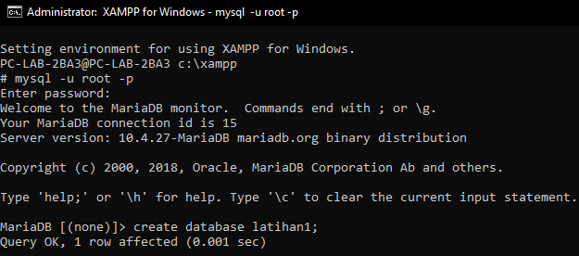
2. select user(), version();  
   Text

   Description automatically generated
3. select curdate();  
   Text

   Description automatically generated
4. select curtime();  
   Text

   Description automatically generated
5. select now();  
   Text

   Description automatically generated
6. select 5 + 5;  
   Text

   Description automatically generated
7. create database latihan2;  
   Text

   Description automatically generated
8. show databases;  
   Text

   Description automatically generated
9. drop database latihan2;

1. show databases;

1. use latihan1;

1. show tables;

1. create table karyawan;  
   A screenshot of a computer

   Description automatically generated with medium confidence
2. create table karyawan (  
   nopeg INT UNSIGNED AUTO_INCREMENT PRIMARY KEY,  
   nama VARCHAR(50) NOT NULL

);

1. show tables;  
   Text

   Description automatically generated
2. describe karyawan;  
   Diagram

   Description automatically generated with medium confidence
3. show columns from karyawan;  
   Diagram

   Description automatically generated with low confidence
4. create table contoh1 (  
   noid INT

);

1. show tables;  
   Text

   Description automatically generated
2. drop table contoh1;  
   Text

   Description automatically generated
3. show tables;  
   Text

   Description automatically generated